# 255 System Design Document

# CS

This template lays out all the different sections that you need to complete for Project Two. Each section has guidance to prompt your thinking. You will need to continually reference the interview transcript as you work to make sure that you are addressing your client’s needs. There is no required length for the final document. Instead the goal is to complete each section based on what your client’s needs are. Remove this note when you are finished, and replace all bracketed text with the relevant information.

## UML Diagrams

### UML Use Case Diagram

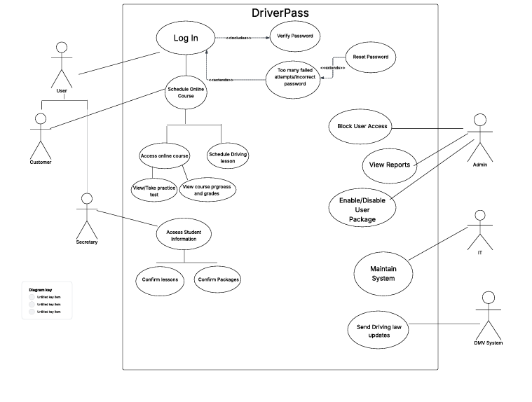

### UML Activity Diagrams

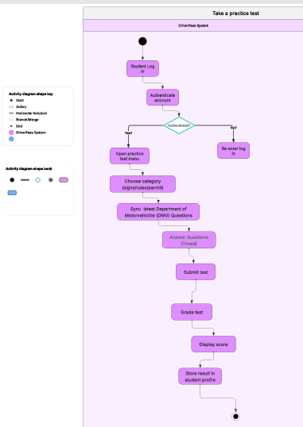

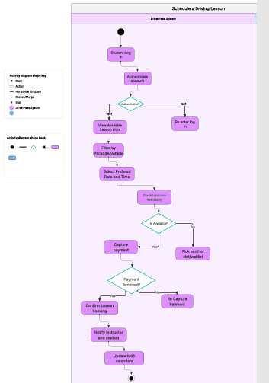

### UML Sequence Diagram

### UML Class Diagram

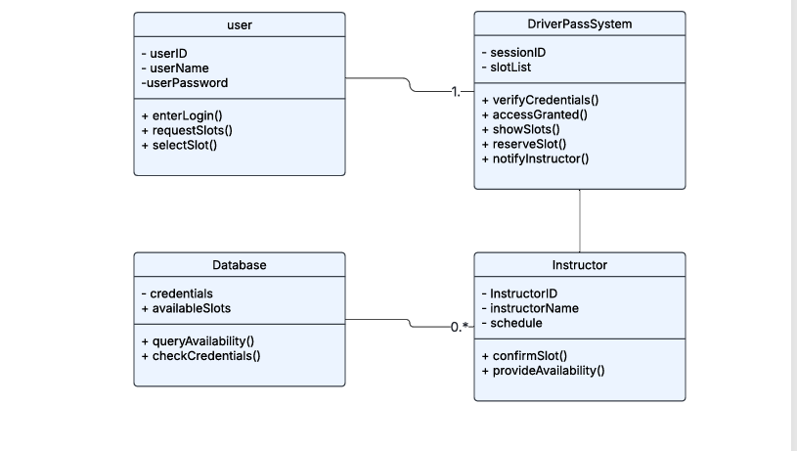

## Technical Requirements

Based on the system design and diagrams, the following technical requirements are identified:

### **Hardware**

* **Servers:** Cloud-based virtual servers with scalable compute and storage resources are required.
* **End User Devices:** Students and staff will use desktops, laptops, tablets, or smartphones with modern browsers.
* **Networking:** High-speed, reliable internet access required for all users is necessary.

### **Software**

* **Frontend:** React-based web application, optimized for desktop and mobile browsers.
* **Backend:** Node.js application server managing scheduling, user roles, and reporting.
* **Database:** MySQL relational database (ACID-compliant, automated backups, and replication).
* **Authentication & Security:** Role-Based Access Control (RBAC), multi-factor authentication (for IT/Admin roles), password hashing, and HTTPS/TLS 1.3 for secure communication.
* **Reporting Tools:** Built-in export functions for CSV and Excel.

### **Tools**

* **Development Tools:** Visual Studio Code, GitHub/GitLab for version control, Docker for containerization.
* **Testing Tools:** Automated unit testing (Jest/Mocha for JavaScript), Selenium for UI testing.
* **CI/CD Tools:** Jenkins or GitHub Actions for continuous integration and deployment.

### **Infrastructure**

* **Cloud Hosting:** AWS or Microsoft Azure for deployment, ensuring 99.9% uptime SLA.
* **Scalability:** Load balancers and auto-scaling to support at least 500 concurrent users.
* **Logging and Monitoring:** CloudWatch (AWS) or Azure Monitor for system logs, error detection, and performance metrics.
* **Disaster Recovery:** Automated daily backups, recovery point objective (RPO) of ≤ 24 hours, recovery time objective (RTO) of ≤ 4 hours.
* **Integration:** RESTful APIs for DMV data updates and potential future third-party integrations (e.g., Google Calendar).